
2026

Building Risk Assessment

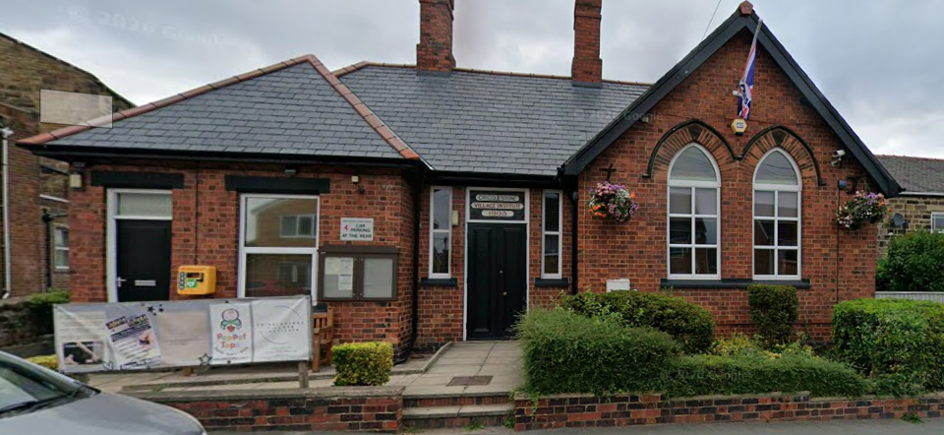
Crigglestone Parish Council
Village Institute
High St
Crigglestone
Wakefield
WF4 3EB

OJ Health and Safety
Chartered Safety and Health Practitioners
Unit 1 Silkwood Park
Fryers Way
Ossett
WF5 9TJ
Telephone: 01924 261789
Email: admin@ojsafety.co.uk
Website: www.ojsafety.co.uk

Contents | Page
Building Risk Assessment | 2
Risk Assessment Matrix | 10
Risk Assessment Explanation | 11
Appendices
Appendix 1: Action Plan | 14

Risk Assessment Number: C001 | Address: Crigglestone Parish Council: Village Institute, High St, Crigglestone, Wakefield WF4 3EB
Relevant Legislation:  - Health and Safety at Work etc. Act 1974  - Management of Health and Safety at Work Regulations 1999  - Workplace (Health, Safety and Welfare) Regulations 1992  - Regulatory Reform (Fire Safety) Order 2005  - Electricity at Work Regulations 1989  - Control of Substances Hazardous to Health Regulations 2002  - Control of Asbestos Regulations 2012  - Health and Safety (First-Aid) Regulations 1981  - Reporting of Injuries, Diseases and Dangerous Occurrences Regulations 2013  - Occupiers' Liability Act 1957  - Occupiers' Liability Act 1984  - Equality Act 2010 |  | Date:  03/07/2026
Scope: This assessment comprises a visual inspection of accessible areas of the building to identify hazards that may present a risk to the health, safety and welfare of occupants, visitors and contractors. It is not a structural survey, building survey or Building Control inspection and should not be relied upon as confirmation of the structural integrity of the building. Where significant defects or evidence of structural movement are identified, a suitably competent Building Surveyor or Structural Engineer should be appointed.

Hazard Identified | Who may be harmed | L | S | Risk rating before  controls applied | Control measures to be implemented | L | S | Risk Rating after  controls applied
Slips, Trips and Falls | Building users, visitors, contractors | 4 | 3 | 12 | • Good standards of housekeeping will be maintained throughout the premises.  • Floors, stairways, corridors and access routes will be kept free from obstruction at all times.  • Spillages will be cleaned immediately and warning signage deployed where necessary.  • Floor coverings will be maintained in a safe condition.  • Adequate lighting will be provided throughout the building.  • Defects presenting a trip hazard will be reported and repaired as soon as reasonably practicable. | 1 | 4 | 4
Fire Safety | Building users, visitors, contractors | 4 | 5 | 20 |  | 1 | 5 | 5
  • A suitable and sufficient Fire Risk Assessment will be completed and reviewed periodically.
  • Means of escape will be kept clear and unobstructed at all times.
  • Fire doors will be maintained in efficient working order and will not be wedged open unless fitted with an approved hold-open device.
  • Fire extinguishers will be maintained, inspected and kept readily accessible.
  • Fire detection and emergency lighting systems will be inspected, tested and maintained in accordance with the relevant British Standards.
  • Appropriate fire safety signage will be provided throughout the premises.
Electrical Safety | Building users, contractors | 4 | 4 | 16 | • Fixed electrical installations will be inspected and tested at the required intervals –once per year  • Portable electrical equipment will be inspected and tested where required.  • Consumer units and electrical cupboards will remain locked or otherwise secured against unauthorised access.  • Defective electrical equipment will be removed from service immediately.  • Only competent persons will carry out electrical work. | 1 | 4 | 4
Statutory Inspection and Maintenance | Building users, visitors, contractors | 4 | 4 | 16 |  | 1 | 4 | 4
  • Statutory inspections will be completed within the required timescales.
  • Inspection certificates and maintenance records will be retained.
  • Defects identified during inspections will be rectified within an appropriate timescale.
  • A planned preventative maintenance programme will be implemented where applicable.
Emergency Escape | Building users and visitors | 4 | 5 | 20 |  | 1 | 5 | 5
  • Emergency escape routes will be kept free from obstruction at all times.
  • Final exit doors will remain readily openable during occupancy.
  • Emergency exit signage will be maintained.
  • Emergency lighting will be inspected, tested and maintained in accordance with the relevant standards.
Housekeeping and Storage | Building users, visitors, contractors | 3 | 3 | 9 | • Materials and equipment will be stored safely.  • Circulation routes will remain unobstructed.  • Waste will be removed regularly.  • Plant rooms, electrical cupboards and storage areas will be kept tidy and secure.  • Combustible materials will be stored appropriately to reduce fire risk. | 1 | 3 | 3
Manual Handling | Staff, contractors | 3 | 3 | 9 | • Manual handling activities will be reduced where reasonably practicable.  • Suitable lifting techniques will be adopted.  • Heavy or awkward loads will be moved using appropriate assistance or mechanical aids where necessary.  • Manual handling training will be provided where appropriate. | 1 | 3 | 3
Contractors | Contractors, building users | 3 | 4 | 12 | • Contractors will provide suitable risk assessments and method statements where required.  • Contractors will be competent to undertake the work.  • Contractors will be informed of emergency procedures and site-specific hazards.  • High-risk works will be appropriately managed and monitored. | 1 | 4 | 4
Security and Unauthorised Access | Building users, visitors | 3 | 4 | 12 |  | 1 | 4 | 4
  • Access to the premises will be appropriately controlled.
  • Service risers, electrical cupboards and plant rooms will remain secured.
  • Keys and access codes will be managed appropriately.
  • Building security will be checked following each period of use.
First Aid | Building users, visitors, contractors | 3 | 3 | 9 |  | 1 | 3 | 3
  • Suitable first aid provision will be available.
  • First aid equipment will be inspected regularly and replenished as necessary.
  • Emergency contact information will be displayed where appropriate.
  • Accidents and incidents will be recorded in accordance with company procedures.
Legionella | Building users, contractors | 3 | 4 | 12 | • Water systems will be managed in accordance with a suitable Legionella Risk Assessment.  • Required inspections, monitoring and maintenance will be completed.  • Records will be retained.  • Any remedial works identified will be completed promptly. | 1 | 4 | 4
Asbestos | Contractors, maintenance personnel, building users | 3 | 5 | 15 |  | 1 | 5 | 5
  • An asbestos survey and register will be maintained where applicable.
  • Contractors will be provided with asbestos information before commencing intrusive works.
  • Suspected asbestos-containing materials will not be disturbed.
  • Asbestos management arrangements will be reviewed periodically.
Accessibility |  | 2 | 4 | 8 |  | 1 | 4 | 4
  Disabled users, visitors
  • Access and egress routes will be maintained in a safe condition.
  • Accessible entrances and facilities will remain available during occupation where reasonably practicable.
  • Appropriate signage will be maintained.
  • Defects affecting accessibility will be reported and rectified.
Welfare Facilities | Building users and visitors | 2 | 3 | 6 |  | 1 | 3 | 3
  • Welfare facilities will be maintained in a clean and hygienic condition.
  • Sanitary facilities will be regularly cleaned and maintained.
  • Hot and cold running water will be provided where applicable.
  • Defects will be reported and rectified promptly.
Lone Working | Parish Council representatives, contractors | 3 | 4 | 12 |  | 1 | 4 | 4
  • Lone working activities will be assessed where applicable.
  • Suitable communication arrangements will be established.
  • Emergency procedures will be communicated to those affected.
  • Concerns or incidents will be reported promptly.
General Building Management | Building users, visitors, contractors | 3 | 4 | 12 |  | 1 | 4 | 4
  • Regular visual inspections of the premises will be undertaken.
  • Defects and hazards identified during inspections will be recorded within the Action Plan.
  • Corrective actions will be allocated, monitored and completed within appropriate timescales.
  • This Building Risk Assessment will be reviewed periodically or following significant changes to the building or its use.

NB: This Building Risk Assessment identifies the generic hazards associated with the management and use of the premises. Any deficiencies or non-conformances identified during the inspection will be detailed within the accompanying Action Plan together with the recommended remedial actions and priority ratings.

This Risk Assessment must be reviewed, amended and signed by the supervisor and the contents understood by the working party prior to work commencing. All operatives will at all times wear the required PPE as designated by their supervisor.
Whilst on site all operatives will keep good housekeeping.
Signed: Date:

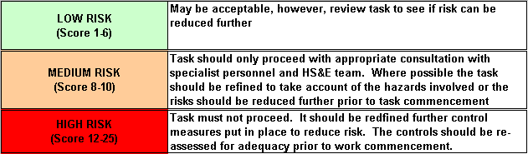
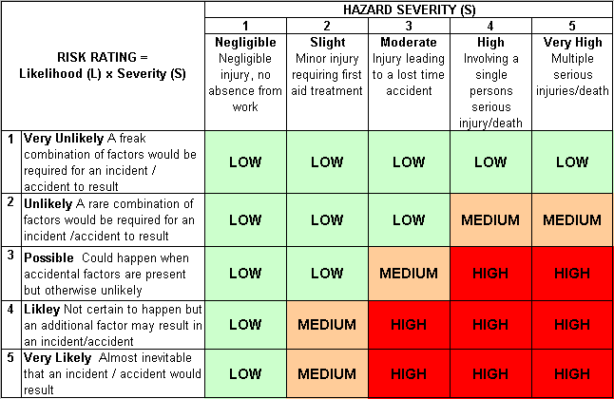

What is a hazard?
The meaning of the word hazard can be confusing. Often dictionaries do not give specific definitions or combine it with the term “risk”. For example, one dictionary defines hazard as “a danger or risk” which helps explain why many people use the terms interchangeably.
There are many definitions for hazard but the more common definition when talking about workplace health and safety is:
A hazard is any source of potential damage, harm or adverse health effects on something or someone under certain conditions at work.
Basically, a hazard can cause harm or adverse effects (to individuals as health effects or to organizations as property or equipment losses).
Sometimes a hazard is referred to as being the actual harm or the health effect it caused rather than the hazard. For example, the disease tuberculosis (TB) might be called a hazard by some but in general the TB-causing bacteria would be considered the “hazard” or “hazardous biological agent”.
What are examples of a hazard?
Workplace hazards can come from a wide range of sources. General examples include any substance, material, process, practice, etc that has the ability to cause harm or adverse health effect to a person under certain conditions. See Table 1.
Examples of Hazards and Their Effects
Workplace Hazard | Example of Hazard | Example of Harm Caused
Thing | Knife | Cut
Substance | Benzene | Leukemia
Material | Asbestos | Mesothelioma
Source of Energy | Electricity | Shock, electrocution
Condition | Wet floor | Slips, falls
Process | Welding | Metal fume fever
Practice | Hard rock mining | Silicosis
As shown in Table 1, workplace hazards also include practices or conditions that release uncontrolled energy like:
- an object that could fall from a height (potential or gravitational energy),
- a run-away chemical reaction (chemical energy),
- the release of compressed gas or steam (pressure; high temperature),
- entanglement of hair or clothing in rotating equipment (kinetic energy), or
- contact with electrodes of a battery or capacitor (electrical energy).
What is risk?
Risk is the chance or probability that a person will be harmed or experience an adverse health effect if exposed to a hazard. It may also apply to situations with property or equipment loss.
For example: The risk of developing cancer from smoking cigarettes could be expressed as “cigarette smokers are 12 times (for example) more likely to die of lung cancer than non-smokers”. Another way of reporting risk is “a certain number ,”Y”, of smokers per 100,000 smokers will likely develop lung cancer” (depending on their age and how many years they have been smoking). These risks are expressed as a probability or likelihood of developing a disease or getting injured, whereas hazards refer to the possible consequences (e.g., lung cancer, emphysema and heart disease from cigarette smoking).
Factors that influence the degree of risk include:
- how much a person is exposed to a hazardous thing or condition,
- how the person is exposed (e.g., breathing in a vapour, skin contact), and
- how severe are the effects under the conditions of exposure.
What is an adverse health effect?
A general definition of adverse health effect is “any change in body function or the structures of cells that can lead to disease or health problems”.
Adverse health effects include:
- bodily injury,
- disease,
- change in the way the body functions, grows, or develops,
- effects on a developing fetus (teratogenic effects, fetotoxic effects),
- effects on children, grandchildren, etc. (inheritable genetic effects)
- decrease in life span,
- change in mental condition resulting from stress, traumatic experiences, exposure to solvents, and so on, and
- effects on the ability to accommodate additional stress.
Will exposure to hazards in the workplace always cause injury, illness or other adverse health effects?
Not necessarily. To answer this question, you need to know:
- what hazards are present,
- how a person is exposed (route of exposure, as well as how often and how much exposure occurred),
- what kind of effect could result from the specific exposure a person experienced,
- the risk (or likelihood) that exposure to a hazardous thing or condition would cause an injury, or disease or some incidence causing damage, and
- how severe would the damage, injury or harm (adverse health effect) be from the exposure.
The effects can be acute, meaning that the injury or harm can occur or be felt as soon as a person comes in contact with the hazardous agent (e.g., a splash of acid in a person’s eyes). Some responses to may be chronic (delayed). For example, exposure to poison ivy may cause red swelling on the skin two to six hours after contact with the plant. On the other hand, longer delays are possible: mesothelioma, a kind of cancer in the lining in the lung cavity, can develop over 20 years or more after exposure to asbestos.
Once the hazard is removed or eliminated, the effects may be reversible or irreversible. For example, a hazard may cause an injury that can heal completely (reversible) or result in an untreatable disease (irreversible)

Appendix 1:
Finding | Action Required | Photographic Evidence | Responsible Person | Priority | Target Completion
PAT testing label displayed an incorrect re-inspection date. | Ensure the Portable Appliance Testing (PAT) label is updated to display the correct re-inspection date. Review all PAT labels throughout the premises to confirm they accurately reflect the inspection records and ensure future inspections are completed within the required timescale  This is noted although it was all discussed on the day of the inspection that the date on the appliance labels for this year was accidently recorded as bi- annually rather than annually. All appliances are tested annually as shown on the regualr maintenance schedule and this labelling issue will be resolved when appliances are next tested( on their one year anniversary) | 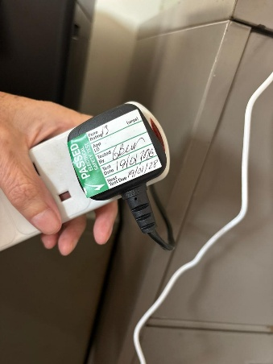 | Chair of the Village Hall Management Committee  The responsible person is the Trustees not one person – it’s the Parish Council | Medium | 14 Days
 | Review the current accident reporting arrangements to ensure all hirers understand their responsibility to report and record accidents and incidents occurring during their use of the premises. Consider strengthening the building hire agreement, displaying clear accident reporting instructions within the building, and implementing a process to verify that any accidents occurring during hire periods are reported to the Parish Council.  The reporting process is clearly displayed on the notice board – this was seen at the time of the inspection. The building is not manned during hires and it's not financially viable to do so. It's also unknown if there any accidents to report? | N/A | Chair of the Village Hall Management Committee | Medium | 1 Month
  An accident book is available; however, there was no evidence that it is being used effectively, with accidents and incidents involving external building users not being recorded despite hirers being instructed to do so.
There was no evidence that a suitable and sufficient Fire Risk Assessment had been completed for the premises. | Arrange for a suitable and sufficient Fire Risk Assessment to be undertaken by a competent person in accordance with the Regulatory Reform (Fire Safety) Order 2005. Ensure any significant findings are documented and that all recommendations arising from the assessment are implemented within appropriate timescales. The Fire Risk Assessment should be reviewed periodically and whenever there are significant changes to the building, its occupancy or its use.  Fire Safety Specialists will complete this for a price of £495 + vat | N/A | Chair of the Village Hall Management Committee | High | 1 Month
There was no evidence that the emergency lighting system was subject to routine monthly function tests or annual servicing. | Implement a programme of inspection, testing and maintenance for the emergency lighting system in accordance with the relevant British Standard. Monthly functional tests should be completed and recorded by a responsible person, with a full annual duration test and service undertaken by a competent contractor. All inspection and maintenance records should be retained for audit purposes.  This is already in place and completed as a part of the Caretakers monthly checklist. The auditor did see a copy of this on the noticeboard in the venues office. | 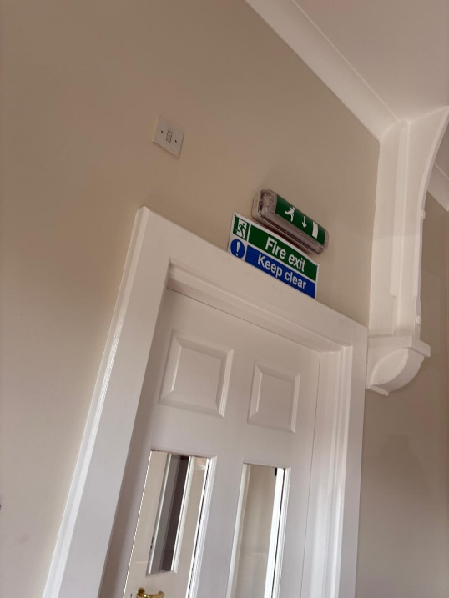 | Chair of the Village Hall Management Committee | High | 1 Month
The compliance tracker records the asbestos survey as 'Not Applicable'; however, presumed asbestos-containing materials are present within the building, including the safe linings. | Review the current asbestos management arrangements and update the compliance tracker accordingly. Arrange for a suitable asbestos management survey to be undertaken, if one is not already available, and implement an Asbestos Management Plan. Presumed asbestos-containing materials, including the safe linings, should be subject to periodic condition inspections (typically at least annually) and monitored to ensure they remain in good condition and are not disturbed.  Inspection report presumed due to lack of access – revisit requested to capture missing items requested price 03/08 from Bradleys | 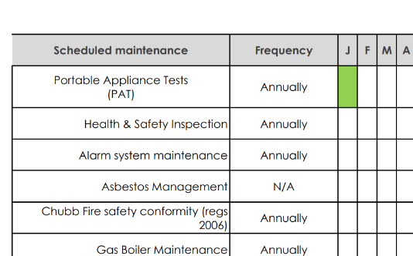 | Chair of the Village Hall Management Committee | High | 1 Month
There was no evidence that a suitable and sufficient Legionella Risk Assessment had been completed for the premises. | Arrange for a suitable and sufficient Legionella Risk Assessment to be undertaken by a competent person to assess the risk associated with the building's water systems. Implement any recommendations arising from the assessment and ensure an appropriate water hygiene management programme is established, including routine monitoring, flushing where required and record keeping. The assessment should be reviewed periodically and whenever there are significant changes to the water system or building use.  Contacted Waterwise 03/08 for prices 01924 681785  Advised that as the venues did not have complex systems and the RA needed to cover only the cold and hot water supplies the RA could be done in house – if the council would like to pay them to attend it is £300 + vat.  The RA should state that the cold water is checked to be below 20 degrees monthly (we can add to the caretakers list) and then the hot water is maintained by the boilers annual service, so no action required by the venue. | N/A | Chair of the Village Hall Management Committee | Medium | 3 Months
It was not confirmed whether suitable insurance arrangements are in place for external hirers using the premises. | Review the current hall hire arrangements to ensure appropriate insurance requirements are established for all external users. Commercial hirers, clubs, instructors and organisations should provide evidence of suitable Public Liability Insurance prior to using the premises. The Village Hall Management Committee should also confirm with their insurer that the hall's insurance policy provides appropriate cover for private hirers where applicable. The hall hire agreement should clearly define the insurance responsibilities of all parties.  This is already in place – regular users insurance documents are requested annually and file.  Contracts for regular users will be revisited in Autumn 2026 | N/A | Village Hall Management Committee | Medium | 1 Month
 | Review the manufacturer's recommendations and implement a suitable programme of periodic inspection and maintenance for the movable partition wall system. As these partitions are regularly moved and rely on tracks, rollers, hinges and locking mechanisms, they may deteriorate through normal use. Routine servicing will help ensure the system operates safely, identify wear or damage before it becomes a safety issue, reduce the risk of trapping or impact injuries, and extend the lifespan of the equipment. Maintenance records should be retained.  Contacted BH Doors Services and Repairs 0808 1220 0911 and requested price for a condition survey and then a maintenance cost 03/08/2026 | 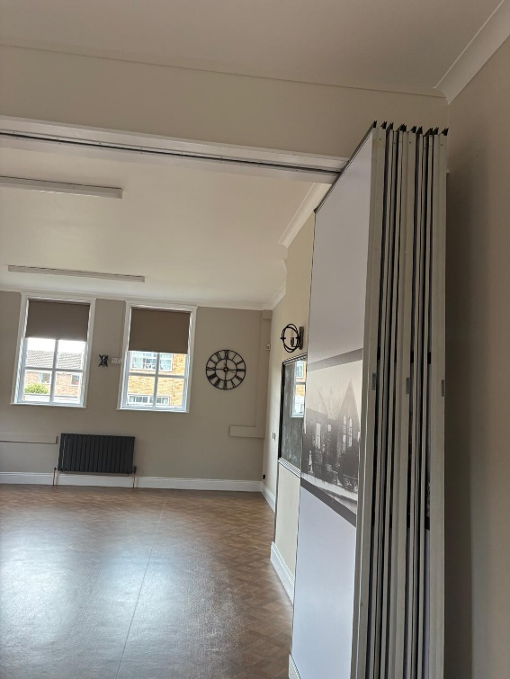 | Chair of the Village Hall Management Committee | Low | 3 Months
  There was no evidence that the movable partition wall system had been subject to routine inspection or maintenance.
There was no evidence that suitable COSHH assessments had been completed for hazardous substances used or stored within the premises. | Review all hazardous substances used or stored within the premises and complete suitable COSHH assessments where required. Safety Data Sheets should be obtained for each product, appropriate control measures implemented, and staff or volunteers responsible for handling hazardous substances made aware of the findings. Hazardous substances should be stored securely and used in accordance with the manufacturer's instructions.  This will take me a half day – date tbc | 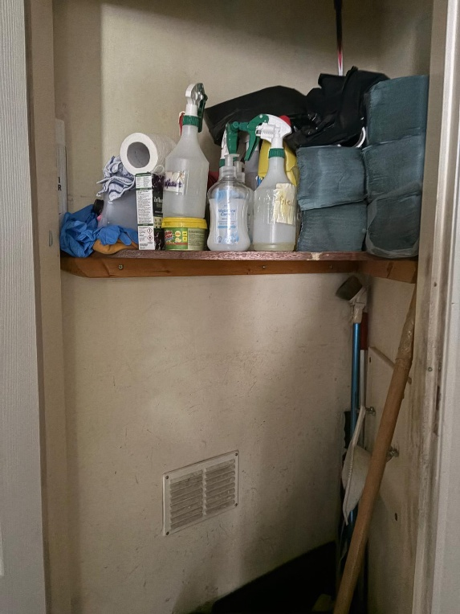 | Chair of the Village Hall Management Committee | Medium | 1 Month

