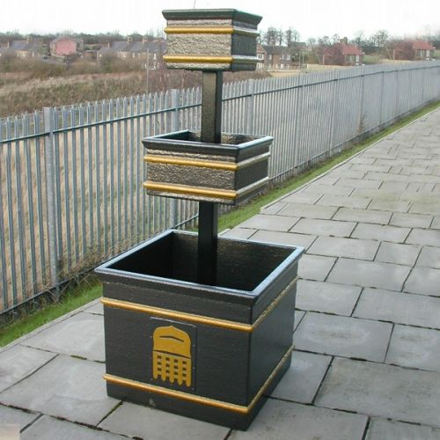
Imagine the 1st and 2nd tier being round
Whole thing in durable green plastic
Potential for using for Nelson Christmas tree in winter
Planting up in the summer
Permanent fixture at the Nelson

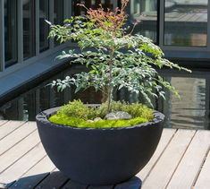
Imagine lots of these in black plastic potted up around the village
They are heavy when filled

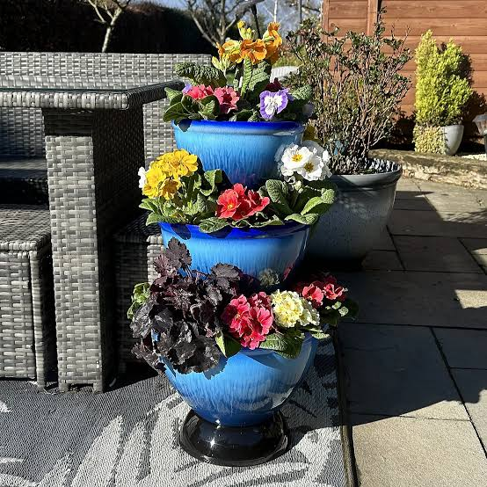
There is a blue plastic one like this,
Imagine this outside HGCC to the left of the front door etc.

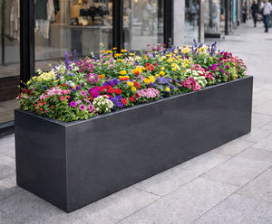
Imagine these planted up around the village or BEP perhaps
They are black plastic with inserts that you remove to plant up in either winter or summer.

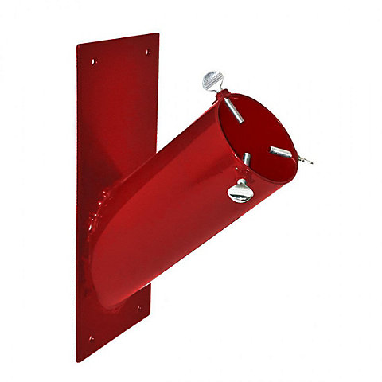
We have 50 of these returned to us from the Christmas trees on lampposts initiative.
What does council wish to have done with them?
Save – where do we store them
Scrap collector – how much will we get that can go towards something else for the village

