What’s on in Crigglestone Parish 2025
Date | Activity | Who | Location | Cost
February 13th  10.30 – 1.00 | Valentines coffee and cake | Open to all. | The Village Institute | Donations
April 21st  1.00 – 3.00pm | Easter Trail | Children with an adult. | Betty Eastwood Park | Donations
May 8th  1.30 – 4.00 | Afternoon tea commemorating the 80th Anniversary of V.E. day | Invitation only limited places for people 80+ years and companion. | The Village Institute | Free
June 7th  4.30 – 9.00 | Line dancing | A family event. | The Village Institute | Ticket only, limited places.
July TBC | Teddy bears Picnic in the Park | Adults and children | Betty Eastwood Park | .Donations
August, | Summer photography challenge | categories 11 years and under. 11 – 16, 16-18, adult. | Crigglestone Parish | Free
August 30th | Summer Fair | Open to all | Hall Green Community Centre | Bring some silver
August 15th | Commemoration of V.J. Day | More details to follow
August TBC. | Self defence. | 11 to 16 | The Village Institute | TBC
September 27th  10.30 – 1.00 | MacMillan coffee morning.  Photography exhibition   | Open to all | The Village Institute | Free  Donations to Macmillan
October TBC | Pumpkins in the Park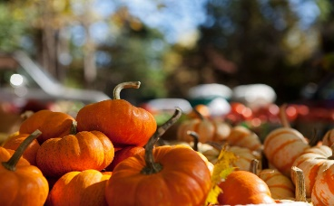 | Open to all.  Bring your pumpkins and voices | Betty Eastwood Park | Donations  Refreshments provided
November 11th | 100 Years of Remembrance Poppies | Open to all. individuals and groups, bring a poppy | The Village Institute | Free  Further details to follow
November 30th  4.30 | The Big switch On | Open to all | The Village Institute | Free
December | Switch On | Open to all | Hall Green Community Centre | Free

